Accoding to the World Economic Forum’s (WEF) Travel & Tourism Competitiveness Report 2019, the main priorities for the Travel & Tourism (T&T) industry is the emerging economies. In other words,

right policies, infrastructure and management systems

Air transport infrastructure improvements show a noticeable increase on route capacity and the number of airlines providing services in individual countries.

future demand for transportation services, especially regarding aviation, might outpace improvements in infrastructure capacity.

(Eurasia, It has some of the best cultural resources in the world and leading infrastructure, especially for ground, port and tourist service infrastructure.)

growing list of digital T&T service

others including ICT readiness, international openness and price competitiveness.

In order to prevent overtourism, each region should maintain the overall number of people that visit a tourist destination at the same time to a limited number without causing destruction of the physical, economic, and sociocultural environment and an unacceptable decrease in the quality of visitors’ satisfaction.

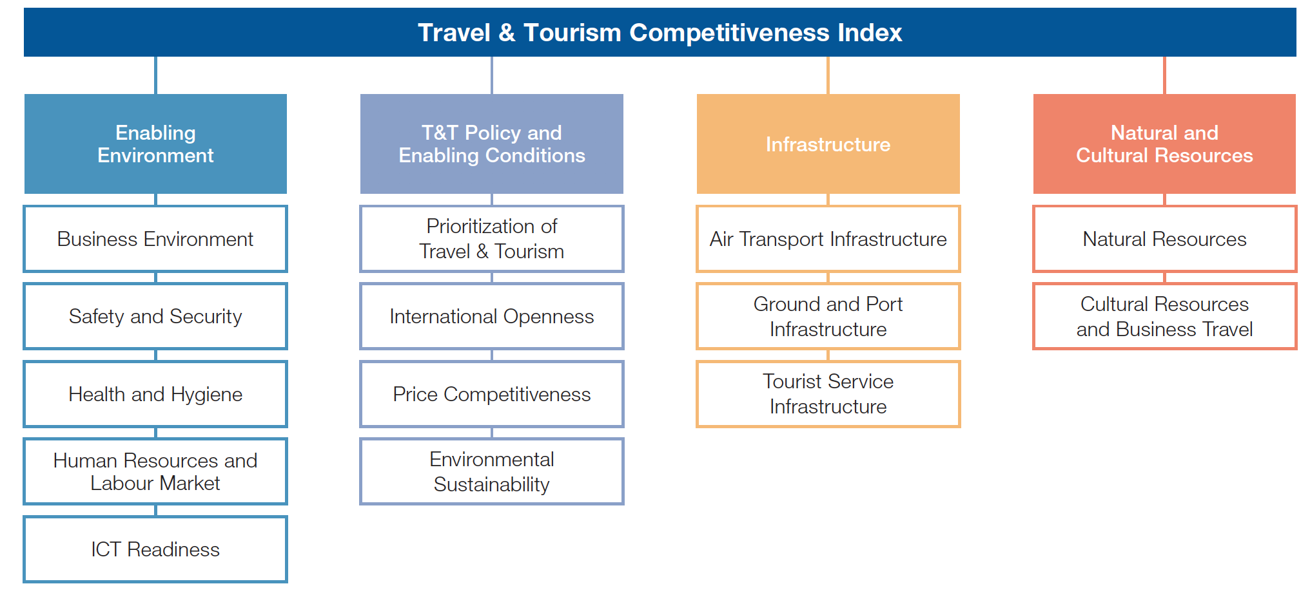

According to the World Economic Forum’s (WEF) Travel & Tourism Competitiveness Report 2019, the main priorities for the Travel & Tourism (T&T) industry include four factors: enabling environment, policy, infrastructure and natural/ cultural resources. The business environment, safety/security, health/hygiene, human resources and labor market, and ICT Readiness are five pillars to determine the competitiveness of a country’s T&T industry. Prioritization of Travel & Tourism, International Openness, Price Competitiveness and environmental sustainability are other four factors inside the policy section. Air Transport, ground, port, and tourist service infrastructure are also the priorities. To be more specific, Air transport infrastructure improvements show a noticeable increase on route capacity and the number of airlines providing services in individual countries. Relatively, cultural resources rank the least among all factors.

I will choose infrastructure to further analysis the Chile case. Since the overall score of international openness and environment is quite high for this country’s current situation, the government of Chile has already had a mature plan to secure its strength in those areas. However, the score for air, ground/port, and tourist service infrastructure are quite low compared to other countries. So, further analysis of those parameters can help Chile better understand its weakness and improve the overall attractiveness.

In order to improve digital transformation and sustainable growth, I choose to analysis the Tourism Infrastructure in my further analysis. The high-speed internet and Wi-Fi networks are necessary to access more advanced technologies. The place to materialized those service is to have mature infrastructure such as online booking hotel, and digital ticketing services and rooms etc. If the Chile government have more investment in overall tourism infrastructures, new customers can be bought because the improvement of living condition. Thus, sustainable growth can be ensured.